**Setting up BSH scripts**

Navigate to where the café scripts are stored, right click on a bsh file and select properties.

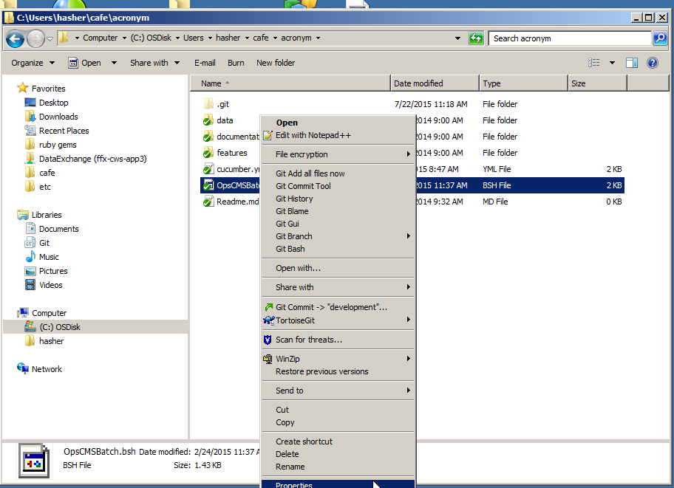

The bsh file should be setup to open with sh.exe files, “Opens with sh.exe”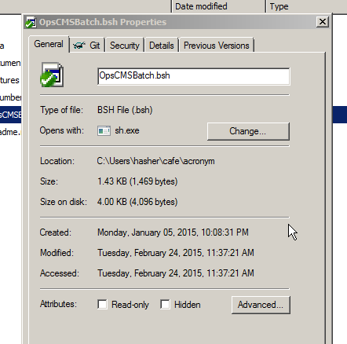

If the bsh file is not set to open with sh.exe click the change button

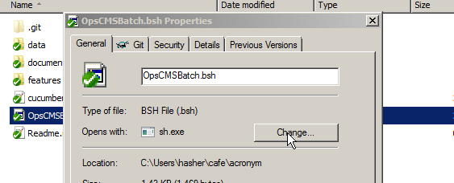

The sh.exe program is located in the C:\Program Files (x86)\Git\bin, click browse, and navigate to the folder, select the file then click open ,

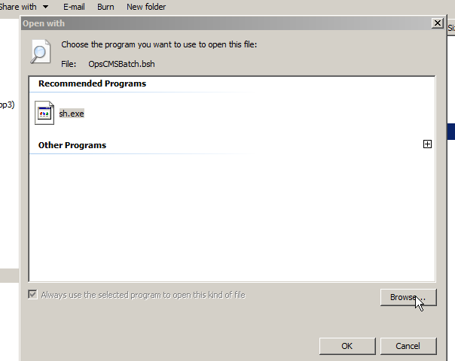

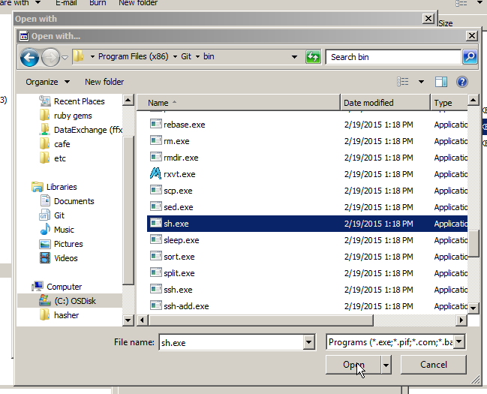

If the bsh file is associated correctly, then the result would be

